**LITERATURE SURVEY**

**ABSTRACT**

Hand written data recognition is becoming more and more important in the modern world. It helps humans ease their jobs and solve more complex problems. Handwritten Digit Recognition is an improving research , which recognizes the written digits of every individual in this world using the dataset provided to Convolutional Neural Network and Artificial Intelligence concepts. This system is developed for zip code or postal code recognition that can be employed in mail sorting. This can help humans to sort mails with postal codes that are difficult to identify.

**HANDWRITTEN DIGIT RECOGNITION**

Handwritten digit recognition is the process to provide the ability to machines to recognize human handwritten digits. It is not an easy task for the machine because handwritten digits are not perfect, vary from person-to-person, and can be made with many different flavors. The handwritten digit recognition is the solution to this problem which uses the image of a digit and recognizes the digit present in the image

**WORKING PRINCIPLE**

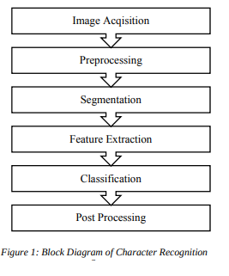

**SURVEY OF PAPERS**

**1. A novel method for Handwritten Digit Recognition with Neural Networks MALOTHU NAGU*1, N VIJAY SHANKAR#2, K.ANNAPURNA**

Character recognition plays an important role in the modern world. It can solve more complex problems and makes humans’ job easier. An example is handwritten character recognition. This is a system widely used in the world to recognize zip code or postal code for mail sorting. There are different techniques that can be used to recognize handwritten characters. Two techniques researched in this paper are Pattern Recognition and Artificial Neural Network (ANN). Both techniques are defined and different methods for each technique is also discussed. Bayesian Decision theory, Nearest Neighbor rule, and Linear Classification or Discrimination is types of methods for Pattern Recognition. Shape recognition, Chinese Character and Handwritten Digit recognition uses Neural Network to recognize them. Neural Network is used to train and identify written digits. After training and testing, the accuracy rate reached 99%.This accuracy rate is very high.

**2. Handwritten Digit Recognition using Machine and Deep Learning Algorithms-2020**

In this paper, Ritik Dixit, Rishika Kushwah, Samay Pashine et. al described that Digit recognition has many applications like number plate recognition, postal mail sorting, bank check processing, etc. In Handwritten digit recognition, we face many challenges because of different styles of writing of different peoples as it is not an Optical character recognition. This research provides a comprehensive comparison between different machine learning and deep learning algorithms for the purpose of handwritten digit recognition and the advantages mentioned are VM has the highest accuracy on training data while on testing dataset CNN accomplishes the utmost accuracy, Trained our deep learning model up to 30 epochs and SVM models according to norms to get the apt outcome

**3. Hao Y., Shi Y., Zhang D., Zhu X. 2001, ”An effective result-feedback**

**neural algorithm for handwritten character recognition‘ International**

**Journal of Neural Parallel & Science Computations, Vol. 9z No. 2,**

**Pp.139~150**

In this paper, a new algorithm of handwritten character recognition based on result-feedback is proposed. It is designed as an effective neural network by adding confidence back-propagation and input modification, thus both pre-processing and recognition operations are closely integrated together. The convergence of the algorithm is proved and many experiments show that the error rate in such a result-feedback neural network (RFNN) can be greatly reduced as well as the robust to environmental noise

**4. Kimura, F. and Shiridhar, M. (1991). Handwritten numerical recognition based on multiple algorithms. Pattern Recognition, no. 10, vol. 24, pp. 969-983**

In this paper, the authors developed two algorithms for application to recognition of unconstrained isolated handwritten numerals. While both algorithms yielded very low error rates, the authors combined the two algorithms in different ways to study the best polling strategy and realized significant improvement in performance.

**5. M. Shridhar and A. Badreldin, Recognition of isolated**

**and simply connected handwritten numerals, Pattern**

**Recognition 19, 1-12 (1986).**

In this paper the authors describe the results of their investigation into the development of a recognition algorithm for identifying numerals that may be isolated or connected, broken or continuous. Using a structural classification scheme, the recognition algorithm is derived as a tree classifier. In an extensive test experiment, an accuracy of 99% was realized with isolated numerals. When connected numerals were also included a recognition accuracy of 93% was obtained.

**6. Handwritten Character Recognition from Images using CNN-ECOC-2020**

In this paper Mayur Bhargab Bora, Dinthisrang Daimary, Khwairakpam Amitab, Debdatta Kandar et. mentioned that The OCR is a process of classifying the optical patterns present in a digital image to the corresponding characters.he OCR is a process of classifying the optical patterns present in a digital image to the corresponding characters.The character recognition is achieved through important steps of feature extraction and classification. The OCR system simulates the human capability to recognize. And the advantages are he CNN is used for feature extraction and ECOC for recognition of characters. In order to find a suitable feature extractor, three popular CNN architectures have been explored, namely LeNet, AlexNet and ZfNet. AlexNet is the most suitable CNN for combining with ECOC, in order to recognize handwritten characters.

**COMPARISION**

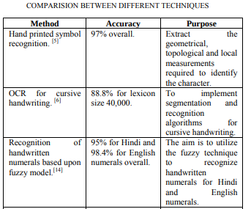

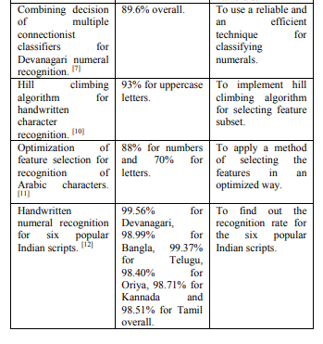

**CONCLUSION**:

The most accurate solution provided in this area directly or indirectly depends upon the quality as well as the nature of the material to be read. Various techniques have been described in this paper for character recognition in handwriting recognition system. A sort comparison is shown between the different methods. The studies in the paper reveals that there is still scope of enhancing the algorithms as well as enhancing the rate of recognition of characters.